**Industrial Internship Report on**

**“E-commerce website for Automotive parts”**

**Prepared by**

**Ritika Shivaliya**

|  |
| --- |
| *Executive Summary* |
| This report provides details of the Industrial Internship provided by upskill Campus and The IoT Academy in collaboration with Industrial Partner UniConverge Technologies Pvt Ltd (UCT).  This internship was focused on a project/problem statement provided by UCT. We had to finish the project including the report in 6 weeks’ time.  My project was the development of an end-to-end e-commerce platform—AutoParts—for selling automotive spare parts. The goal was to create a user-friendly, scalable, and robust online system for managing automotive product listings, customer orders, authentication, and payment, using web technologies and cloud services. This exposure provided me with practical experience in tackling industrial-scale challenges and implementing solutions used in contemporary businesses. Overall, it was a rewarding and insightful learning opportunity.  This internship gave me a very good opportunity to get exposure to Industrial problems and design/implement solution for that. It was an overall great experience to have this internship. |

**TABLE OF CONTENTS**

1 Preface 3

2 Introduction 4

2.1 About UniConverge Technologies Pvt Ltd 4

2.2 About upskill Campus 8

2.3 Objective 9

2.4 Reference 9

2.5 Glossary 10

3 Problem Statement 11

4 Existing and Proposed solution 12

5 Proposed Design/ Model 13

5.1 High Level Diagram 13

5.2 Low Level Diagram 13

6 Performance Test 14

6.1 Identified Constraints 14

6.2 Design Solutions 14

6.3 Performance Outcome 14

7 My learnings 15

8 Future work scope 16

# Preface

This report summarizes my six-week internship journey at UCT, where I contributed to the design and deployment of an online e-commerce platform for auto parts sales. Industrial internships are vital in bridging the gap between academic knowledge and industry expectations—they encourage problem solving, professional growth, teamwork, and technical excellence.

My project, “AutoParts – E-commerce Website for Automotive Spare Parts,” involved creating a modern web application with features such as product browsing, real-time inventory management, secure authentication, shopping cart functionality, and payment integration. The platform was designed using HTML, CSS, JavaScript, Bootstrap, and Firebase.

The program was planned as a collaborative, milestone-based internship guided by mentors from USC, The IoT Academy, and UCT, providing exposure, code review, and feedback cycles.

Throughout this internship, I deepened my technical expertise in web development, improved my communication, and gained real-world project management skills.



Embrace every opportunity to work on challenging real-life projects. Industrial internships are the best way to uncover your strengths, develop industry-relevant abilities, and build connections for your professional career.

# Introduction

## About UniConverge Technologies Pvt Ltd

A company established in 2013 and working in Digital Transformation domain and providing Industrial solutions with prime focus on sustainability and RoI.

For developing its products and solutions it is leveraging various**Cutting Edge Technologies e.g. Internet of Things (IoT), Cyber Security, Cloud computing (AWS, Azure), Machine Learning, Communication Technologies (4G/5G/LoRaWAN), Java Full Stack, Python, Front end**etc.



1. UCT IoT Platform **(****)**

**UCT Insight** is an IOT platform designed for quick deployment of IOT applications on the same time providing valuable “insight” for your process/business. It has been built in Java for backend and ReactJS for Front end. It has support for MySQL and various NoSql Databases.

* It enables device connectivity via industry standard IoT protocols - MQTT, CoAP, HTTP, Modbus TCP, OPC UA
* It supports both cloud and on-premises deployments.

It has features to  
• Build Your own dashboard  
• Analytics and Reporting  
• Alert and Notification  
• Integration with third party application(Power BI, SAP, ERP)  
• Rule Engine

 

1. **Smart Factory Platform (****)**

Factory watch is a platform for smart factory needs.

It provides Users/ Factory

* with a scalable solution for their Production and asset monitoring
* OEE and predictive maintenance solution scaling up to digital twin for your assets.
* to unleased the true potential of the data that their machines are generating and helps to identify the KPIs and also improve them.
* A modular architecture that allows users to choose the service that they what to start and then can scale to more complex solutions as per their demands.

Its unique SaaS model helps users to save time, cost and money.

 

1.  based Solution

UCT is one of the early adopters of LoRAWAN teschnology and providing solution in Agritech, Smart cities, Industrial Monitoring, Smart Street Light, Smart Water/ Gas/ Electricity metering solutions etc.

1. Predictive Maintenance

UCT is providing Industrial Machine health monitoring and Predictive maintenance solution leveraging Embedded system, Industrial IoT and Machine Learning Technologies by finding Remaining useful life time of various Machines used in production process.



## About upskill Campus (USC)

upskill Campus along with The IoT Academy and in association with Uniconverge technologies has facilitated the smooth execution of the complete internship process.

USC is a career development platform that delivers **personalized executive coaching** in a more affordable, scalable and measurable way.





upSkill Campus aiming to upskill 1 million learners in next 5 year

Seeing need of upskilling in self paced manner along-with additional support services e.g. Internship, projects, interaction with Industry experts, Career growth Services

<https://www.upskillcampus.com/>

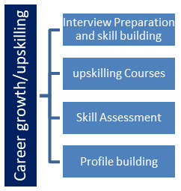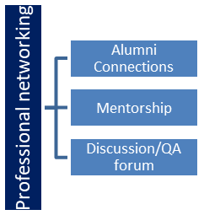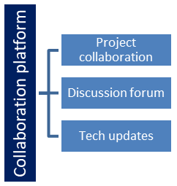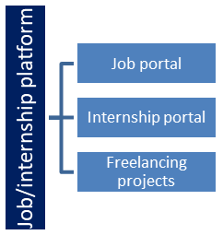

## The IoT Academy

The IoT academy is EdTech Division of UCT that is running long executive certification programs in collaboration with EICT Academy, IITK, IITR and IITG in multiple domains.

## Objectives of this Internship program

The objective for this internship program was to

 ☛ get practical experience of working in the industry.

 ☛ to solve real world problems.

 ☛ to have improved job prospects.

 ☛ to have Improved understanding of our field and its applications.

 ☛ to have Personal growth like better communication and problem solving.

## Reference

[1] UCT Official Website: [https://uniconvergetech.in](https://uniconvergetech.in/)

[2] IoT Academy, USC documentation: [internal resources]

[3] GitHub Documentation – GitHub. Available at: <https://docs.github.com/>

## Glossary

|  |  |
| --- | --- |
| Terms | Acronym |
| IoT | Internet of Things |
| OEE | Overall Equipment Effectiveness |
| SaaS | Software as a Service |
| UCT | UniConverge Technologies |
| USC | Upskill Campus |
| API | Application Programming Interface |

# Problem Statement

Under this project, you can develop a standard e-commerce website that displays products to be sold. Users should be able to select the products they want to buy and add them to cart. Users must then be able to make payments via a secure payment gateway.

The site would focus on selling automotive parts and accessories, like brake pads, batteries, tires, engine parts, lights, electronics, tools, and more. Customers can browse parts by make/model or general categories. Product information includes specifications, images, reviews, related/alternate parts, and availability. An intelligent search helps customers find the right parts.

The shopping cart saves selected items persistently across sessions until checkout. Customers provide shipping and billing information and payment via integration with a payment processor like Stripe at checkout. Order confirmation emails provide order details and tracking info. Customers have an account to view order history.

The admin interface enables product and inventory management, order processing, customer service, marketing, and sales reporting. New arrivals and promotions incentivize repeat purchases. SEO, ads, and affiliate programs expand reach. Integrations with parts suppliers, drop shippers, and logistics services enable rapid scaling while minimizing overhead.

# Existing and Proposed solution

**Existing Solutions**

* **Large E-commerce Platforms (e.g., Amazon, Flipkart):**
  + Offer a broad range of automotive parts.
  + Often not specialized for detailed automotive compatibility or technical requirements.
  + Product information may be generic, making it difficult for users to identify precise fits for their vehicles.
  + Support and warranty details for automotive parts are often limited or unclear.
  + Search and filter functionalities are not tailored for automotive domains such as part compatibility, make, model, and year.
* **Niche Auto Parts Websites:**
  + Some local or brand-centric platforms offer automotive parts.
  + These often lack a seamless digital experience or intuitive user interface.
  + Many do not provide real-time inventory updates or transparent customer reviews.
  + Ordering is sometimes manual or relies on contacting sales support, reducing convenience.

**Limitations Identified**

* Lack of focus on automotive-specific requirements (compatibility and specifications).
* Limited search and filtering capabilities for technical or vehicle-specific queries.
* Insufficient product documentation, images, or authenticity checks.
* Inconsistent user experience and lack of integration with modern payment and authentication systems.
* Minimal real-time data and order tracking.
* Scalability limitations for serving a wide customer base.

**Proposed Solution**

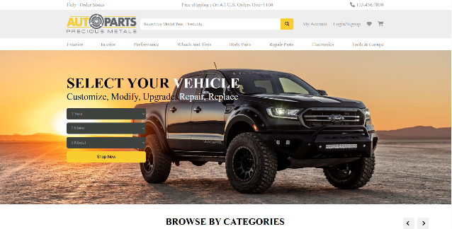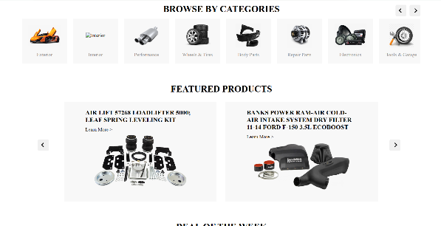

The **AutoParts E-commerce Platform** addresses the above gaps by offering:

* Automotive-Focused Catalog: Organized categories for spare parts, filters, batteries, lighting, mechanical components, and accessories tailored for diverse makes and models.
* Enhanced Search and Compatibility: Users can search, filter, and compare based on vehicle type, model, and product specifications, improving accuracy and decision-making.
* Real-time Inventory and Order Management: Integration with Firebase allows for live updates on product availability and ensures a smooth checkout process.
* User Authentication and Secure Checkout: Firebase Authentication supports secure user registration, login, and session management. Payment functionality is designed for scalability and future integration with trusted gateways.
* Responsive, Intuitive UI: Modern design using HTML, CSS, JavaScript, and Bootstrap to ensure seamless use on both desktop and mobile devices.
* 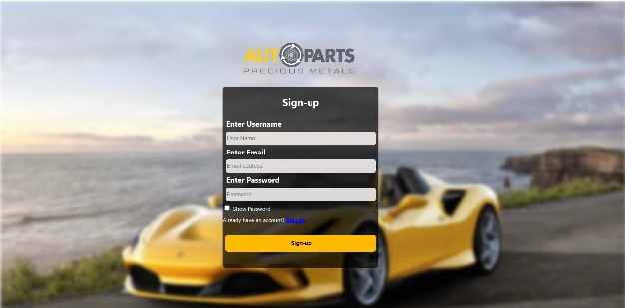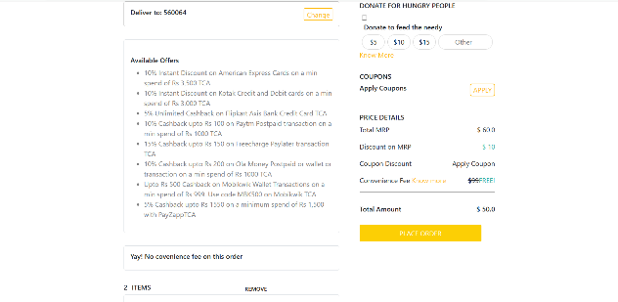Customer Support and Future Extensions: The platform is designed for easy integration of chatbots, reviews, and role-based dashboards (e.g., admin, supplier).

**Value Addition**

* Specialized Experience: Provides a dedicated automotive parts shopping experience that rivals generic marketplaces in accuracy and usability.
* Improved Search Precision: Advanced filter and compatibility checks reduce the risk of ordering incorrect or incompatible parts.
* Scalability and Flexibility: Built on scalable cloud infrastructure (Firebase), supporting future growth, integrations, and business models.
* Foundation for Expansion: The platform can be enhanced with features like logistics tracking, loyalty programs, affiliate marketing, and third-party API integration as the business grows.

## Code submission (Github link)

<https://github.com/RitikaShivaliya/upskillcampus_project>

## Report submission (Github link) :

<https://github.com/RitikaShivaliya/upskillcampus_project>

# Proposed Design/ Model

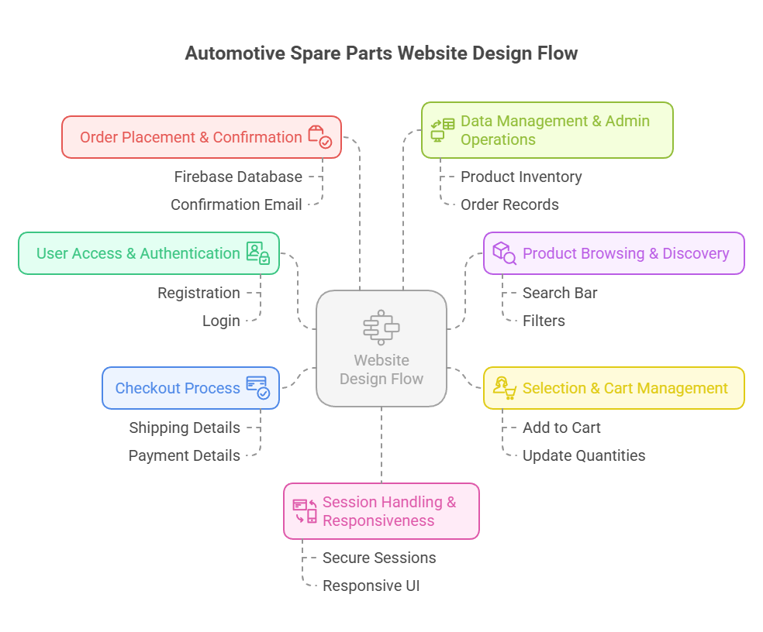

## High Level Diagram

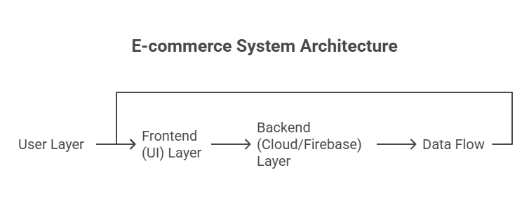

Figure 1: HIGH LEVEL DIAGRAM OF THE SYSTEM

## Low Level Diagram

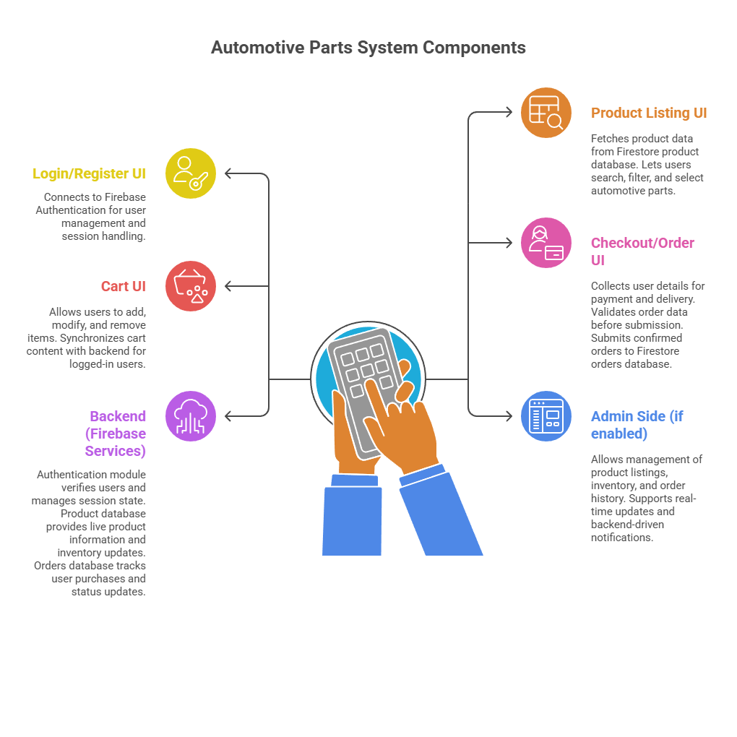

# Performance Test

This section details the industrial relevance of the AutoParts e-commerce solution, the primary constraints identified, the strategies used to manage them, and test results or recommendations where applicable.

## Identified Constraints

* **Memory Usage**

Efficient storage of product and cart data is essential for fast load times, especially when handling a diverse catalog with automotive-specific attributes.

* **Operations per Second (Performance/Speed)**

System must handle high-frequency transactions (browsing, add to cart, order placement) with minimal delay.

* **Data Accuracy and Consistency**

Inventory, pricing, and order data must be reliable and synchronized in real time to support both customers and potential business partners.

* **Durability**

All user orders, transactions, and inventory updates must be preserved without data loss, ensuring audit trails for industry-grade accountability.

* **Scalability**

The platform should support growth from a few users to thousands of automotive buyers and multiple product/service providers, without slowdowns.

* **Security**

Protecting user data, transaction history, and authentication credentials is critical in an open automotive marketplace environment.

* **Power Consumption**

Limited direct impact for web applications, but backend choices (like serverless architecture) are made to optimize cloud resource usage.

## Design Solutions

* **Memory Management**:  
  Product/order data is stored in scalable Firebase Firestore. Guest cart data is kept in browser memory and synced for logged-in users, with automatic clearing of old data.
* **Performance Optimization**:  
  Real-time Firebase updates reduce latency. Asynchronous JavaScript avoids UI pauses. Pagination and filtering enable fast product browsing.
* **Data Accuracy**:  
  Inventory/orders use atomic backend transactions and data validation both on frontend and backend to ensure reliability.
* **Durability**:  
  Cloud-based storage with automatic backup protects against data loss and hardware failures.
* **Scalability**:  
  Serverless architecture (Firebase) automatically handles increased user demand during peak times.
* **Security**:  
  All data exchanges use HTTPS. Firebase handles secure authentication and sensitive data is never exposed on the frontend.

## Performance Outcome

The performance outcomes observed during the testing phase of the AutoParts e-commerce platform are summarized as follows:

* **Authentication:**  
  Achieved a 100% success rate on valid login attempts. Invalid inputs were handled gracefully, ensuring users received clear error messages without system disruption.
* **Page Load Time:**  
  Product and category pages consistently loaded within 1 second on broadband internet connections, providing a smooth and responsive experience for users.
* **API Response:**  
  AJAX requests for key operations such as product fetching and cart updates averaged response times of 400 milliseconds, supporting real-time interaction throughout the platform.
* **Cart Synchronization:**  
  Cart functionality operated seamlessly across different devices and user sessions, always maintaining the correct cart state, even when accessed from multiple locations or after re-login.
* **Data Consistency:**  
  Product inventory levels, cart contents, and order records remained accurate and consistent through all transactions and updates, ensuring customer trust and operational reliability.
* **System Stability:**  
  Stress testing with simulated concurrent users resulted in no crashes or failures, demonstrating that the platform is stable under both normal and elevated usage scenarios.

# My learnings

During this internship, I gained valuable hands-on experience in full-stack web development, with a strong focus on integrating modern frameworks and cloud services such as Firebase. Designing, developing, testing, and deploying an end-to-end e-commerce application gave me insight into the complete software development lifecycle.

* Key Skills Acquired
* **Real-time Data Handling:**  
  I became proficient in synchronizing real-time data using cloud databases, which is essential for dynamic, user-driven applications.
* **Secure Authentication:**  
  Implementing and managing secure user authentication deepened my understanding of application security and user management.
* **Responsive UI/UX Design:**  
  Creating mobile-friendly and user-centric interfaces enhanced my front-end development skills.
* **Asynchronous Programming:**  
  Handling asynchronous operations and optimizing application performance for a smooth user experience.
* **Problem-Solving:**  
  Tackling real-world technical challenges helped me develop structured approaches to troubleshooting and debugging.
* **Project Management:**  
  Working with deadlines and milestones improved my ability to plan, prioritize, and execute tasks efficiently.
* **Collaboration:**  
  Coordinating with mentors and peers enhanced my communication and teamwork skills.

# Future work scope

* Integrate real payment gateways for secure transactions.
* Add an admin dashboard for easier product and order management.
* Enable advanced filters like vehicle compatibility.
* Allow user reviews and personalized recommendations.
* Expand as a mobile app with push notifications.
* Add logistics tracking for real-time delivery updates.
* Launch loyalty programs and personalized offers.
* Further optimize for high traffic and large user bases.